Ophthalmology-Based Sample Selection in the PediBIRN Retinal-Injury Analysis
Purpose. This note answers three questions: (1) how entry into the retinal-analysis sample was determined, (2) whether ophthalmologist confirmation functions as a filter for data collection or analysis, and (3) how this may create sample-selection / verification-bias concerns for retinal injury and for the observed retinal-injury–abuse association.

1. How was entry into the retinal-analysis sample decided?
- What the paper states directly. The pooled PediBIRN records contained 973 eligible children, but the study analyzed the subset of 701 records with documented results of an ophthalmologist’s examination.
- What this means operationally. A case enters the retinal-analysis sample only if an ophthalmology examination was obtained and documented. In the uploaded workbook, the practical gate variable is Q5.3.1.10 Ophthalmology evaluation?.
- What the paper does not fully explain. The paper does not provide a full upstream clinical decision rule for why some children received ophthalmology evaluation and others did not. It does not say that every child automatically received an eye exam, nor does it spell out a universal protocol such as ‘order ophthalmology whenever seizure + diffuse HIE are present’ or ‘only order ophthalmology when abuse is suspected.’
- Most precise interpretation. Entry into the retinal-analysis sample was determined by whether the eye examination result existed in the record, but the paper leaves open whether the decision to obtain that exam was discretionary, site-specific, severity-triggered, abuse-suspicion-triggered, or protocolized.
Variable chain for sample entry:
- Pre-existing clinical / imaging / history variables are available first (for example: age, seizure, altered consciousness, circulatory compromise, diffuse HIE, inertial subdural, abuse-related history/injury fields).
- Then the selection variable is observed: Q5.3.1.10 Ophthalmology evaluation?
- Only after Q5.3.1.10 = 1 do the retinal findings become observable for the study outcome.

2. Is ophthalmologist confirmation a filter that determines which data get collected?
- Yes for retinal-outcome measurement. The retinal outcome in the paper is defined using ophthalmologist-confirmed retinal findings. The relevant retinal-measurement variables in the workbook are:
- Q5.3.1.10 Ophthalmology evaluation? -> gate / filter for whether retinal findings are available for analysis
- Q5.3.2.8 Retinoschisis confirmed by an ophthalmologist? -> one component of the retinal outcome
- Q5.3.2.9 Retinal hemorrhage(s) described by an ophthalmologist as dense, extensive, covering a large surface area, and/or extending to the ora serrata? -> the other component of the retinal outcome
- Derived retinal outcome. The paper’s outcome severe retinal injury is constructed as: severe_retinal_injury = 1 if Q5.3.2.8 = 1 OR Q5.3.2.9 = 1.
- Not a general filter for all other case data. The broader clinical and radiologic covariates do not depend on the ophthalmology exam in the same way. They are collected from the wider clinical workup and can exist even if Q5.3.1.10 = 0.
- Examples of non-retinal variables that can exist without ophthalmology evaluation:
- Q2.3.1 Age (months)
- Q4.2.1 Respiratory compromise
- Q4.2.2 Circulatory compromise
- Q4.2.3 Seizure
- Q4.2.4 Altered consciousness
- Q4.4.7 Subarachnoid hemorrhage
- Q4.4.4 + Q4.4.5.* Subdural location / distribution (used to construct contact subdural and inertial subdural)
- Q4.4.8–Q4.4.10 Parenchymal injury fields (used to construct cortical and subcortical brain injury)
- Q4.4.12–Q4.4.14 HIE fields (used to construct focal HIE and diffuse HIE)
- Q5.2.* and Q5.3.2.* abuse-related history / suspicious-injury fields
- Best short summary. Ophthalmology evaluation is a filter for retinal-outcome observability and for entry into the paper’s retinal-analysis sample. It is not the general filter for whether the rest of the clinical / imaging data exist.

3. Could this create sample-selection bias, and how could that affect retinal injury and abuse?
- Retinal injury is the clearest concern. Because severe retinal injury is observed only when Q5.3.1.10 = 1, the retinal outcome is verified in only a subset of the full eligible sample. If the probability of Q5.3.1.10 = 1 depends on severity-related or abuse-related variables, then the retinal-analysis sample is selected rather than random.
- Variables that could plausibly influence whether ophthalmology was obtained:
- Q4.2.3 Seizure
- Q4.2.4 Altered consciousness
- Q4.2.1 Respiratory compromise
- Q4.2.2 Circulatory compromise
- Q4.4.12–Q4.4.14 Diffuse HIE
- Q4.4.4 + Q4.4.5.* Inertial subdural
- Q5.2.* history-based abuse concern
- Q5.3.2.1–Q5.3.2.7 suspicious extracranial injuries used in abuse classification
- Why this matters. If children with seizure, diffuse HIE, altered consciousness, circulatory compromise, inertial subdural, or stronger abuse suspicion were more likely to get eye exams, then the 701 examined children would be enriched for severe or abuse-suspected cases. In that setting, the measured prevalence of retinoschisis, severe retinal hemorrhage, and severe retinal injury could differ from the prevalence that would have been observed if all eligible children had been examined.
- This is a selection / verification-bias issue. The outcome is not observed for everybody; it is observed only for the subset who were verified by ophthalmology. That makes the decision to examine the eye part of the data-generating process.
- Why this may also affect the observed retinal-injury–abuse association:
- Formal abuse variable. The paper’s abuse variable is not defined by retinal findings alone. It is based on a priori criteria such as caregiver admission, unbiased witness, denial of trauma in a preambulatory child, historically inconsistent history, or the presence of two or more suspicious injuries.
- Relevant workbook fields for abuse classification. These include history items in Q5.2.* and suspicious-injury items such as Q5.3.2.1–Q5.3.2.5 and Q5.3.2.7, plus the scalding-burn item Q4.3.5.
- Why selection still matters. Even though abuse is not mechanically defined by retinal injury, the association between retinal injury and abuse can still be distorted if clinicians were more likely to request ophthalmology in cases already considered severe or suspicious for abuse. In that situation, both retinal findings and abuse classification may become concentrated in the examined subgroup.
- Careful conclusion. There is a plausible selection / verification-bias concern for retinal injury, and that may also affect the observed retinal-injury–abuse association. However, the paper itself does not directly test the selection mechanism, and it does not define abuse by retinal findings alone.

4. Variable-level representation of the problem
Selection variable: S = 1 if Q5.3.1.10 Ophthalmology evaluation? = 1; S = 0 otherwise.
Observed retinal outcome only when S = 1: Y = severe retinal injury, where Y is built from Q5.3.2.8 and Q5.3.2.9.
Potential determinants of S: age (Q2.3.1), seizure (Q4.2.3), altered consciousness (Q4.2.4), respiratory compromise (Q4.2.1), circulatory compromise (Q4.2.2), subdural distribution variables (Q4.4.4 + Q4.4.5.*), HIE variables (Q4.4.12–Q4.4.14), and abuse-related history/injury fields (Q5.2.*, Q5.3.2.*).
Interpretation: if the same variables that predict retinal injury also help determine whether ophthalmology was obtained, then the retinal-analysis sample may be selected in a way that distorts the observed associations.

5. Variables most useful for an empirical check of the selection issue
To investigate whether ophthalmology evaluation was non-random, the most direct comparison is Q5.3.1.10 = 1 versus Q5.3.1.10 = 0.
- Suggested continuous / ordinal variables (good for skewed distribution plots):
- Age (Q2.3.1)
- Duration of altered consciousness (derived from Q4.2.4–Q4.2.7)
- Suggested binary variables (good for stacked bar charts):
- Clinical hypoxia or ischemia (derived from Q4.2.1 OR Q4.2.2)
- Diffuse HIE (derived from Q4.4.12–Q4.4.14)
- Seizure (Q4.2.3)
- Circulatory compromise (Q4.2.2)
- Respiratory compromise (Q4.2.1)
- Inertial subdural (derived from Q4.4.4 + Q4.4.5.*)
- Altered consciousness (Q4.2.4)
- Abuse classification / abuse reconstruction (from Q5.2.* and Q5.3.2.*)

6. Direct answers to the three questions
1. How was the decision to have an ophthalmologist confirm made?
- The paper does not fully describe the upstream clinical rule. What it does show is that the retinal-analysis sample consisted of the subset with documented ophthalmologist examination. So, operationally, sample entry depended on whether the exam result existed in the record, but the paper does not fully explain why some children received that exam and others did not.
2. Is confirmed by ophthalmologist a filter that determines which data get collected for a case?
- It is a filter for retinal-outcome measurement, not for all case data. Q5.3.1.10 determines whether the retinal findings used to construct severe retinal injury can be observed. The broader clinical and imaging variables are available more generally and do not depend on the eye exam in the same way.
3. Could this lead to sample-selection bias and biased classification into retinal hemorrhage or abuse?
- Yes, there is a plausible concern for retinal injury because the outcome is observed only in the ophthalmology-tested subset. That can also affect the observed retinal-injury–abuse association if the tested subgroup is enriched for severe or abuse-suspected cases. But the paper does not directly test that mechanism, and abuse is not defined by retinal findings alone.

Descriptive Plots Comparing Ophthalmology Evaluation vs No Ophthalmology Evaluation
These figures compare children with and without documented ophthalmology evaluation in the paper. They are descriptive checks of potential selection into the retinal-analysis sample. They do not by themselves prove selection bias or causality. For binary variables, the stacked bars show within-group percentages; for age, the curves show smoothed distributions. The abuse figure uses the approximate reconstruction described earlier in this note.

Figure A1. Age distribution by ophthalmology evaluation
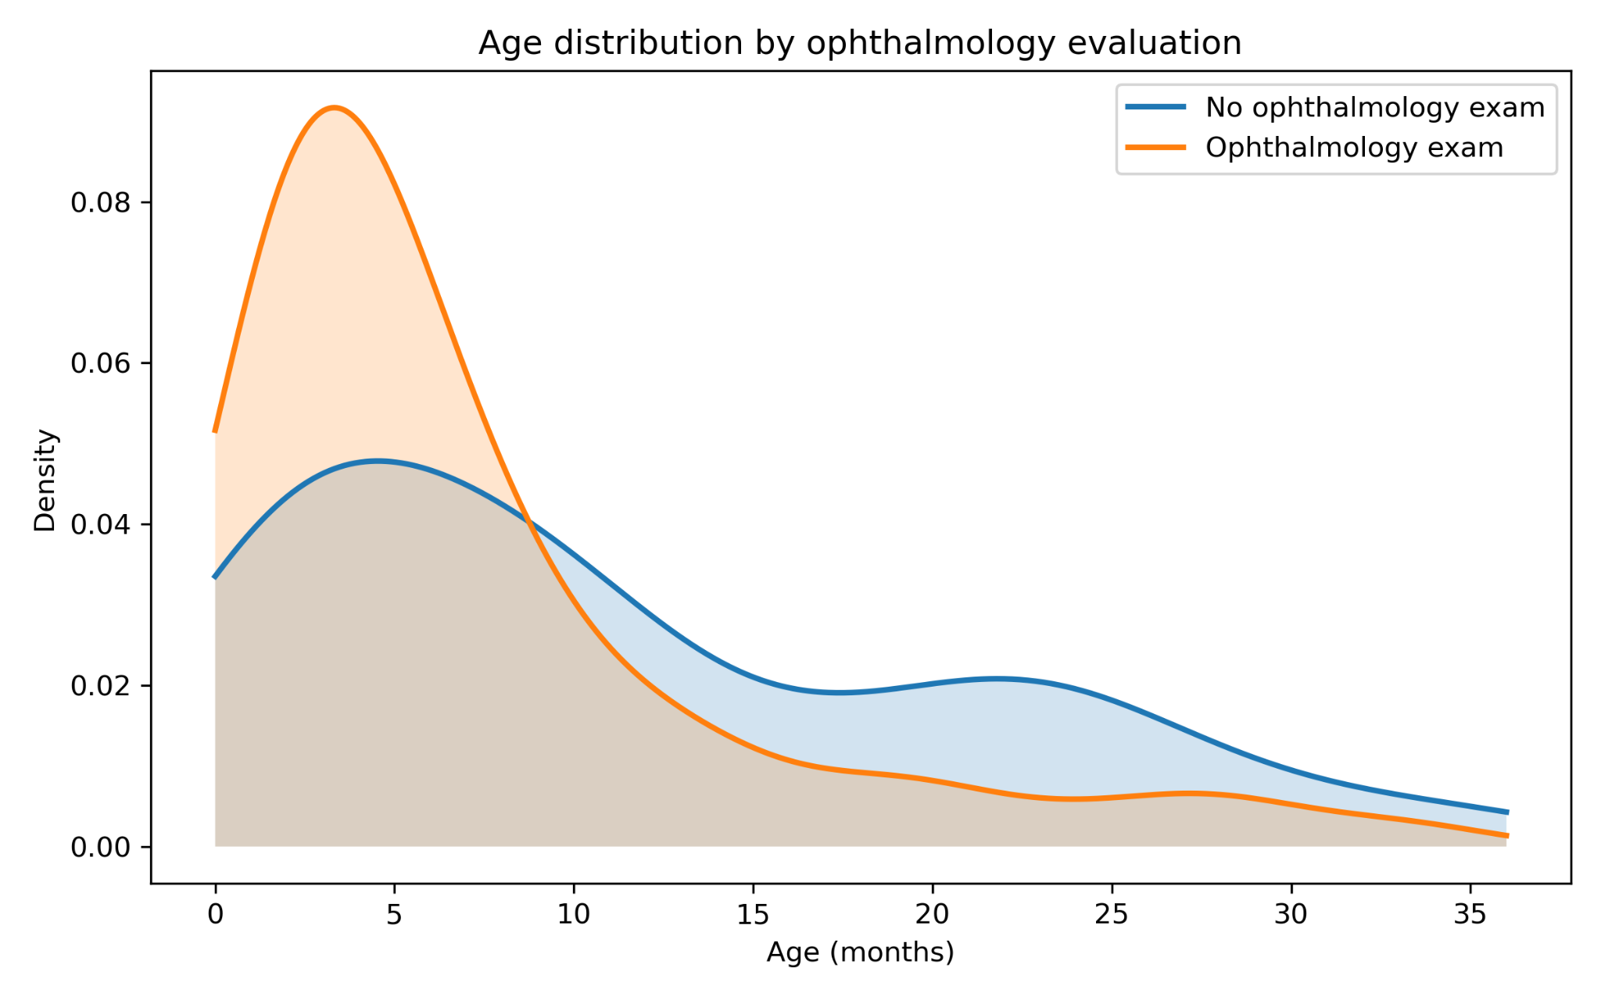
Interpretation. Children with documented ophthalmology evaluation are concentrated at younger ages, while the non-exam group is more spread toward older ages. This suggests that the ophthalmology-tested subset differs in age composition from the non-tested subset, which is relevant because age itself may correlate with both abuse concern and clinical presentation.

Figure A2. Clinical hypoxia / ischemia by ophthalmology evaluation
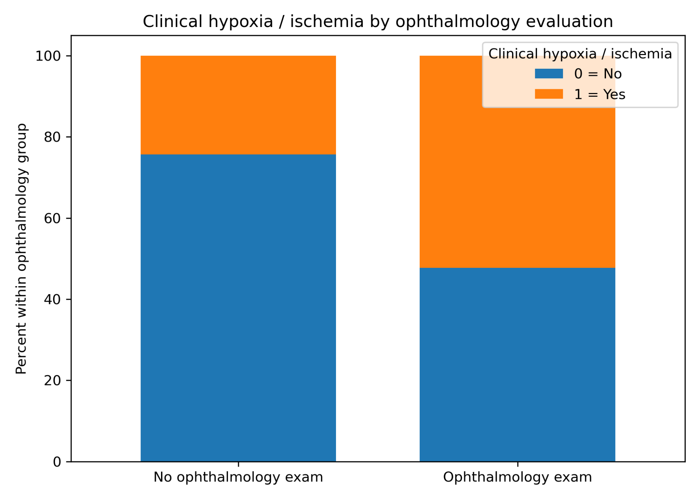
Interpretation. Clinical hypoxia / ischemia is more common in the ophthalmology-evaluated group than in the non-evaluated group. If severity-related features such as respiratory or circulatory compromise make ophthalmology evaluation more likely, then retinal outcome verification may depend partly on baseline clinical severity.

Figure A3. Diffuse HIE by ophthalmology evaluation
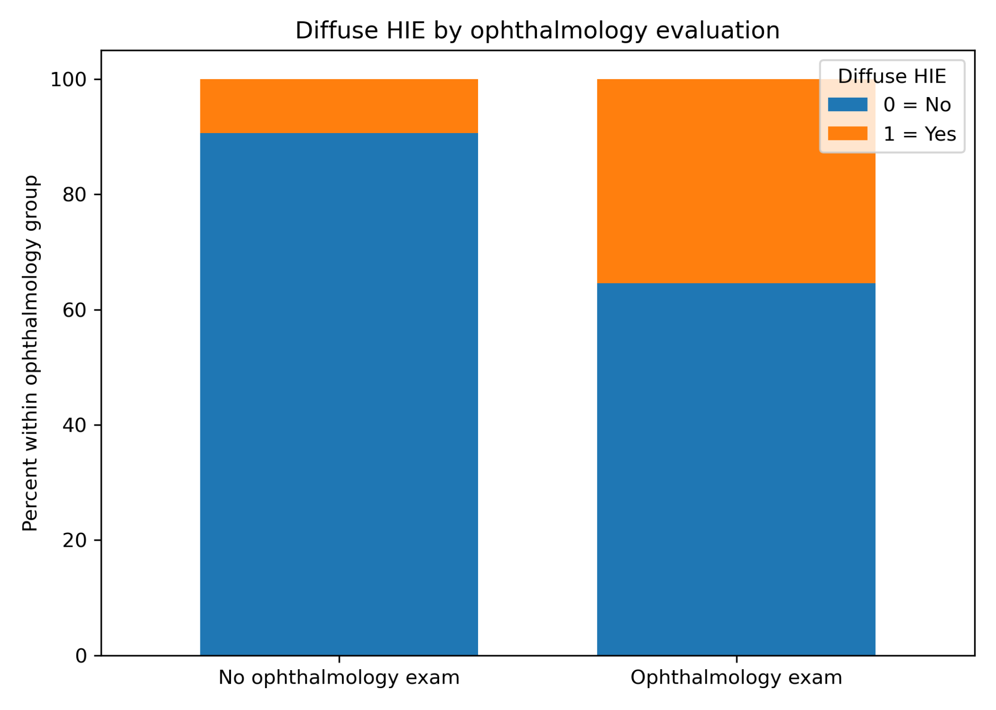
Interpretation. Diffuse HIE is more common in the ophthalmology-evaluated group. Because diffuse HIE is a severity-related imaging marker in the paper’s framework, this pattern is consistent with the possibility that more severe neurologic cases were more likely to receive eye examination.

Figure A4. Seizure by ophthalmology evaluation
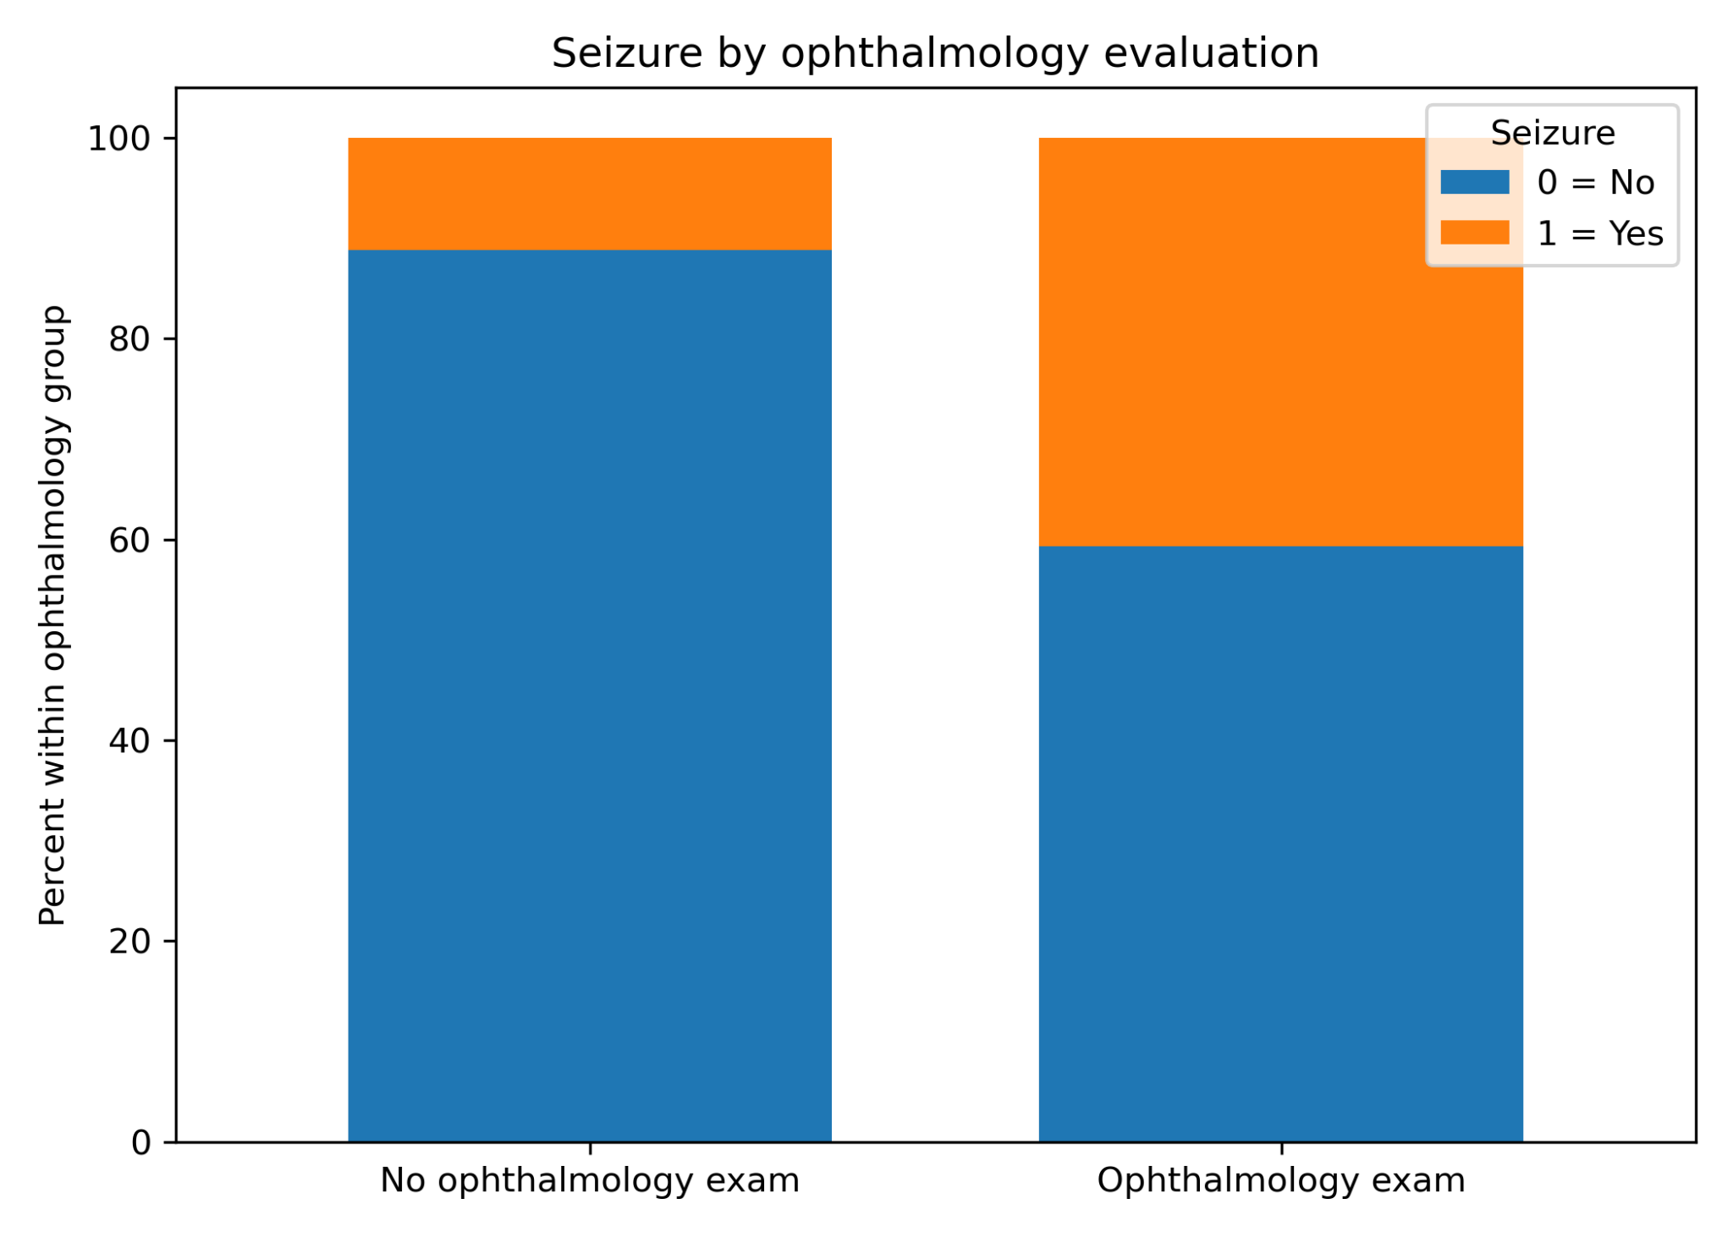
Interpretation. Seizure is more frequent among children who received ophthalmology evaluation. This again points to a non-random difference between examined and non-examined cases.

Figure A5. Altered consciousness by ophthalmology evaluation
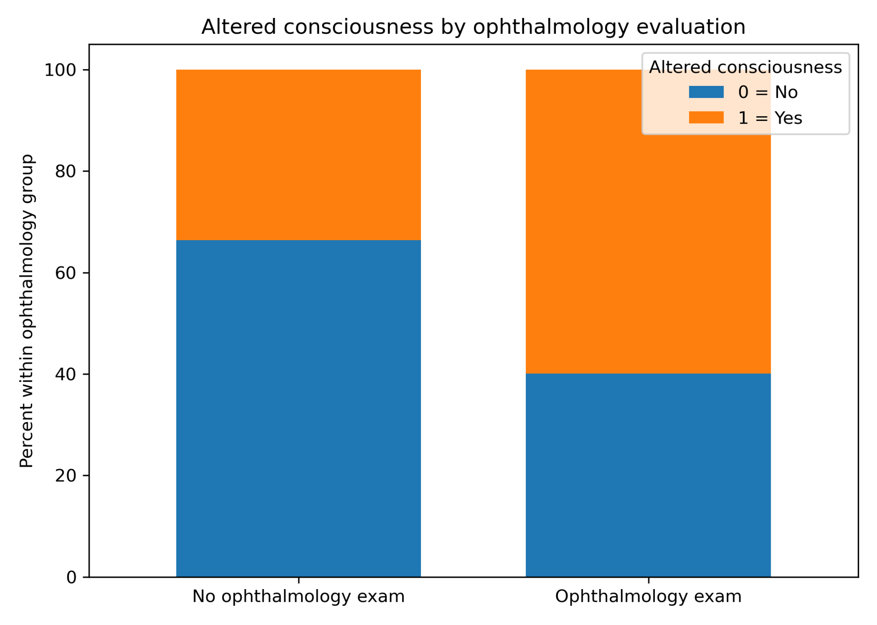
Interpretation. Altered consciousness is more common in the ophthalmology-evaluated group. That matters because altered consciousness is both clinically important and part of the paper’s inferred inertial-injury framework.

Figure A6. Inertial subdural by ophthalmology evaluation
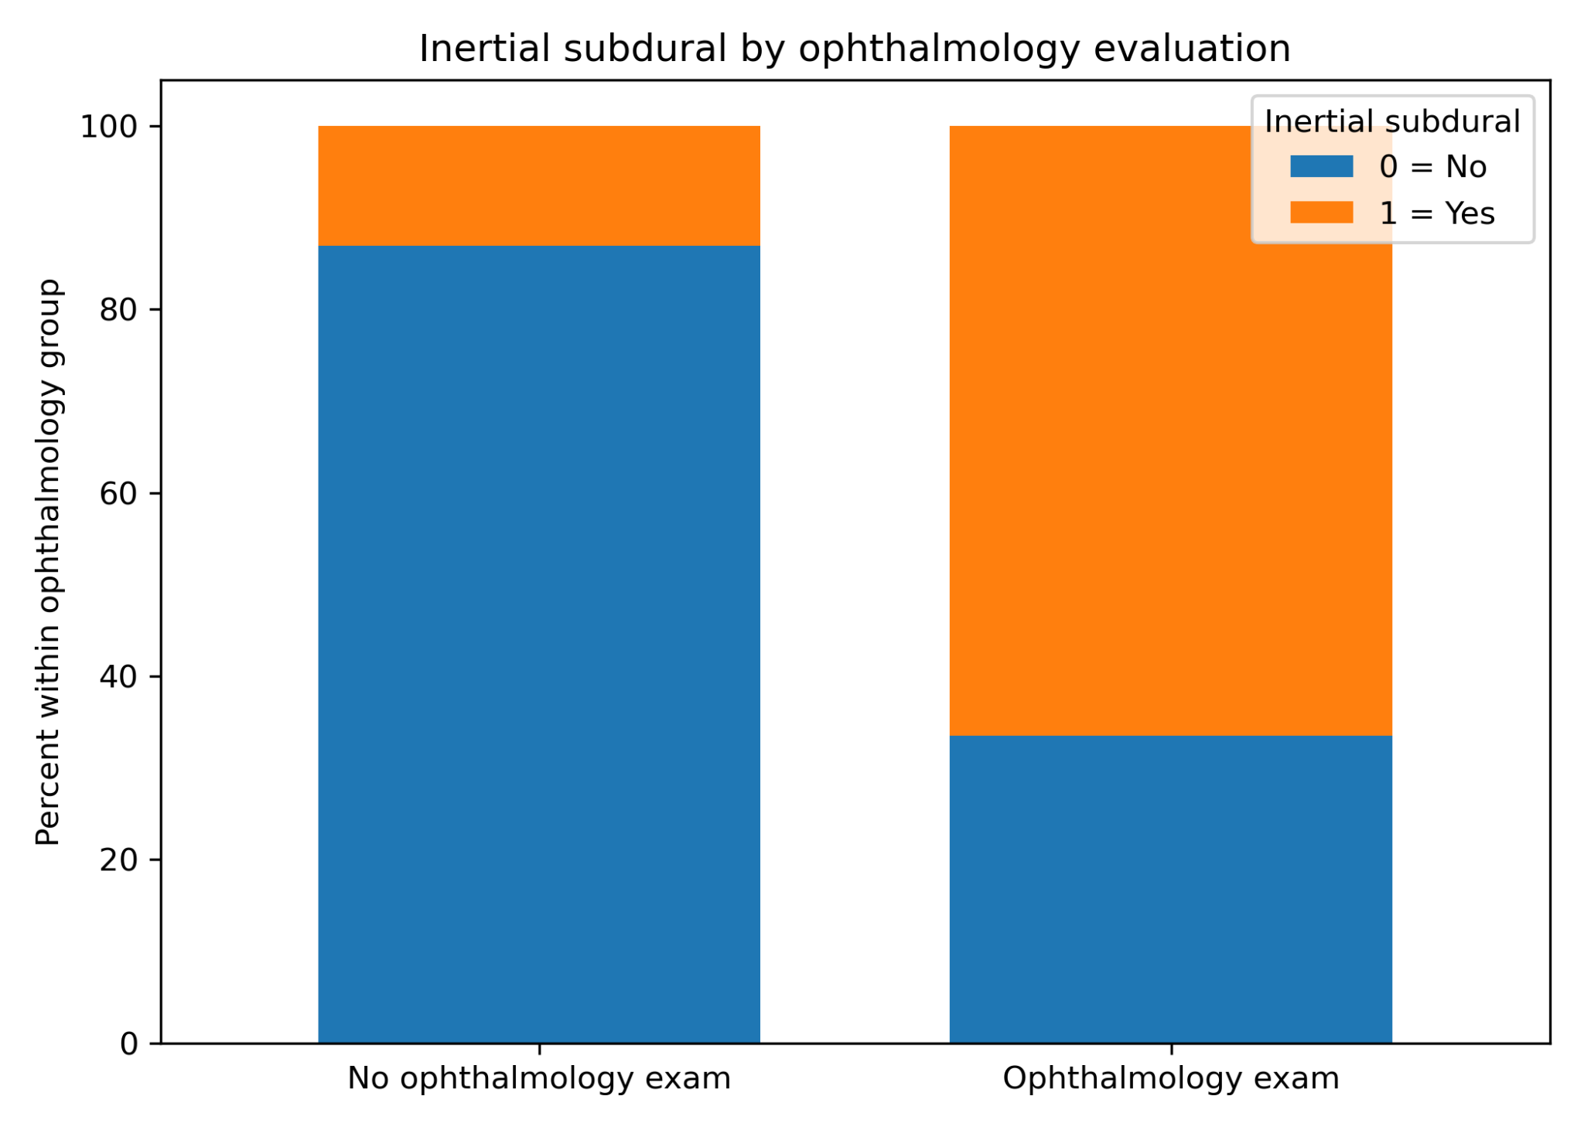
Interpretation. Inertial subdural is more frequent in the ophthalmology-evaluated group. If cases with bilateral or interhemispheric subdural bleeding were more likely to receive ophthalmology evaluation, then the measured retinal sample may be enriched for the very features later analyzed against retinal injury.

Figure A7. Abuse (approximate reconstruction) by ophthalmology evaluation
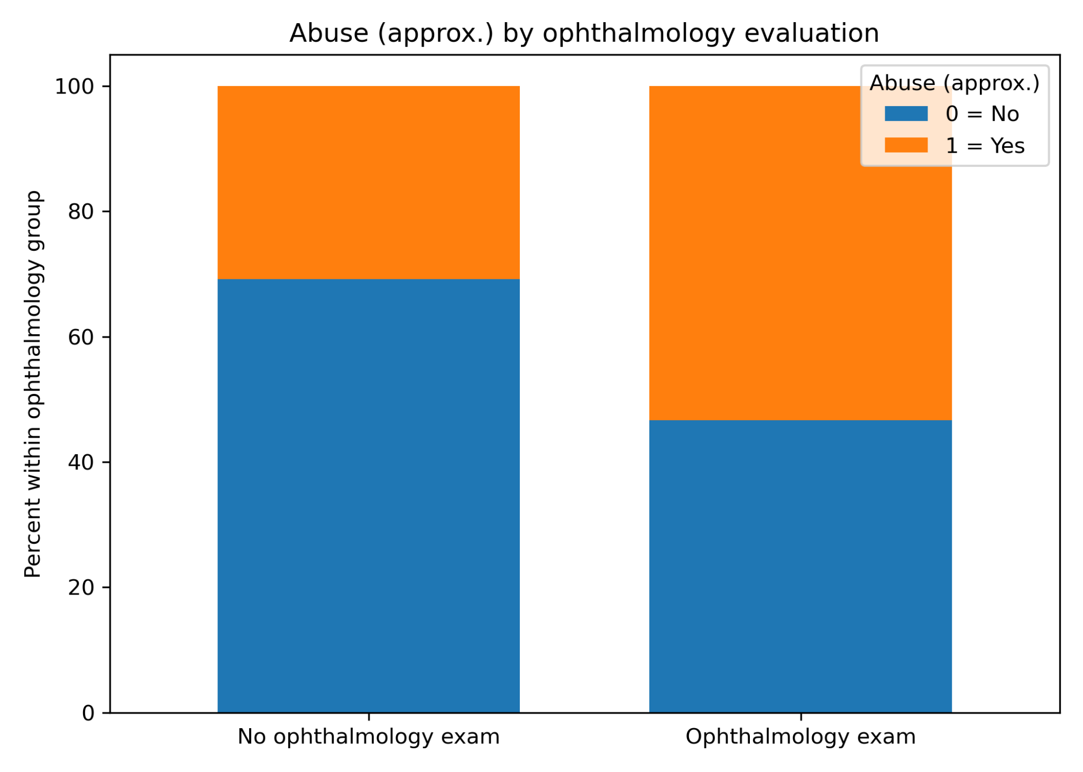
Interpretation. The ophthalmology-evaluated group has a higher share of abuse-positive cases under the approximate reconstruction used in this paper. This does not show that abuse was defined by retinal findings; rather, it suggests that abuse-suspected cases may have been more likely to undergo ophthalmology evaluation. That is the mechanism by which the retinal-injury–abuse association could be affected by selection into the examined subgroup.
Overall descriptive takeaway. Across age and several severity- or abuse-related variables, the ophthalmology-evaluated subgroup looks systematically different from the non-evaluated subgroup in the paper. That pattern is consistent with a plausible sample-selection / verification-bias concern: retinal outcomes were only measured in a subgroup that may already have differed on clinically important covariates.

